APBD Natural History Study Registry
Steps for Navigating the Registry

- Go to the APBD NHS Registry website at: apbd-fan.iamrare.org.

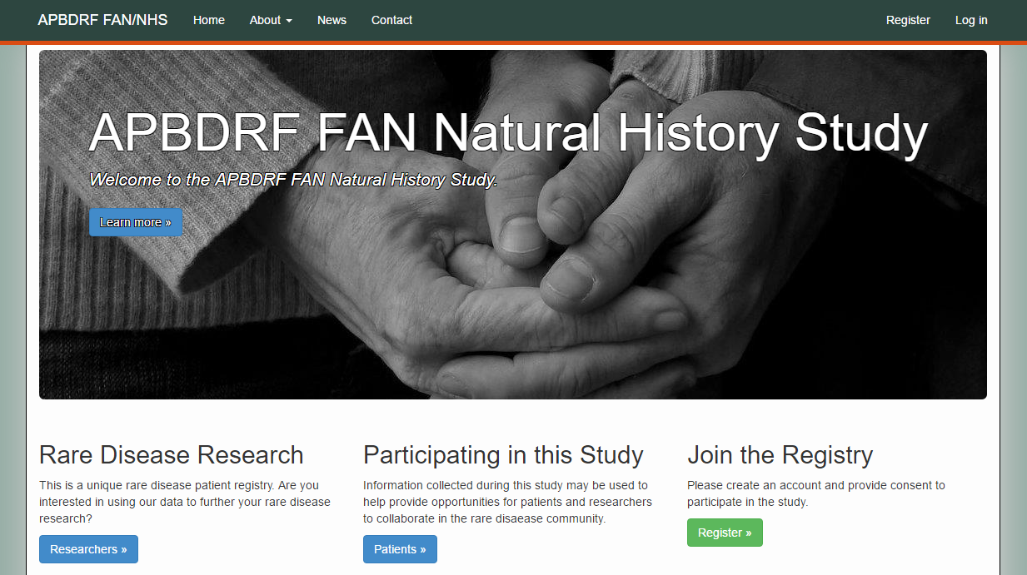

- Click on the green Register button.
- Read the "Terms and Conditions" document.

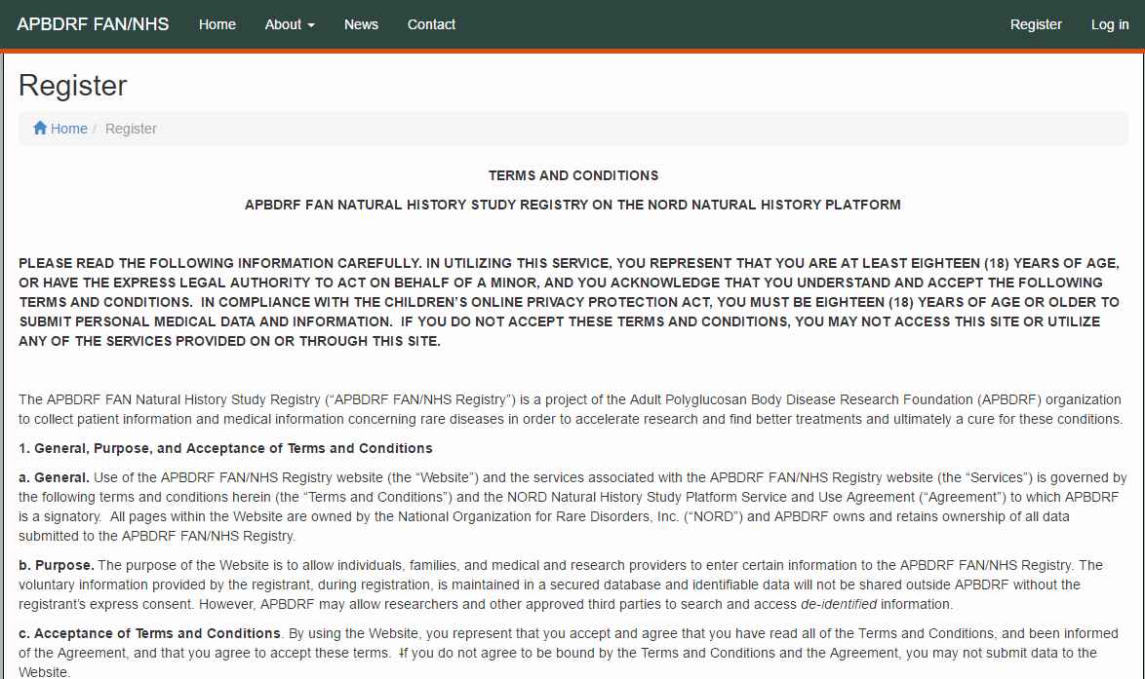
- Fill in the requested information.
- Agree to the Terms and Conditions
- Opt-in or out of reasons to be contacted by study personnel
- Click Create Account button

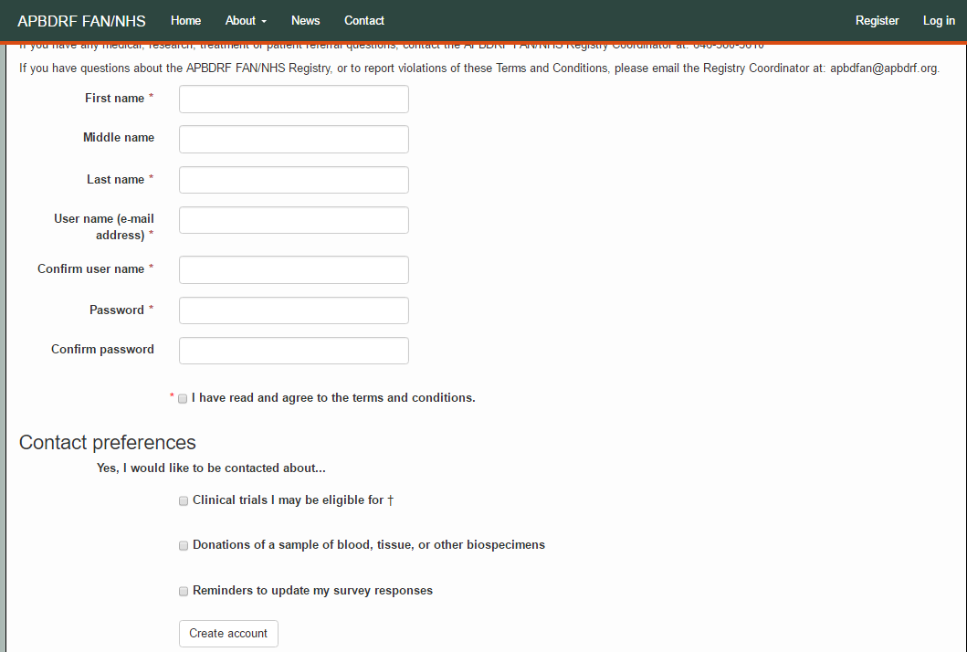

- A confirmation email will be sent to the email address that was provided during registration. Confirm registration by copying the Confirmation Token from your email.
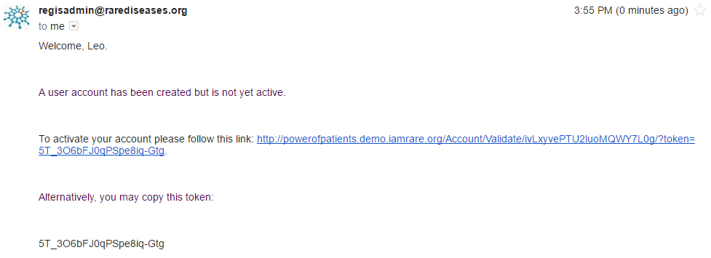

- Paste the confirmation token into the “Confirmation Code” field. Click Submit.
  - If the confirmation email has not been received after a few minutes, click “Resend confirmation email” at the bottom of the page. Be sure to check spam folders for the email confirmation.

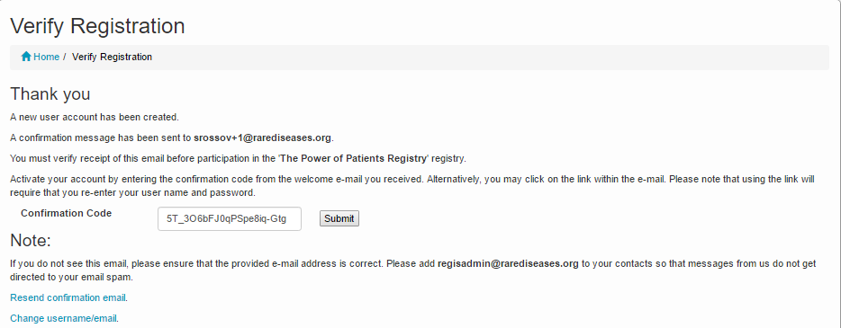

- Click on “Participant Enrollment.”
- Select the appropriate Option for granting consent.
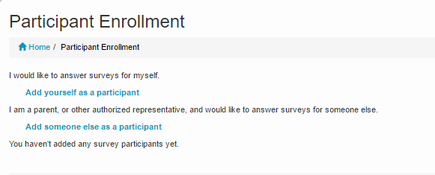

- Fill in the fields as they apply to the Study Participant.

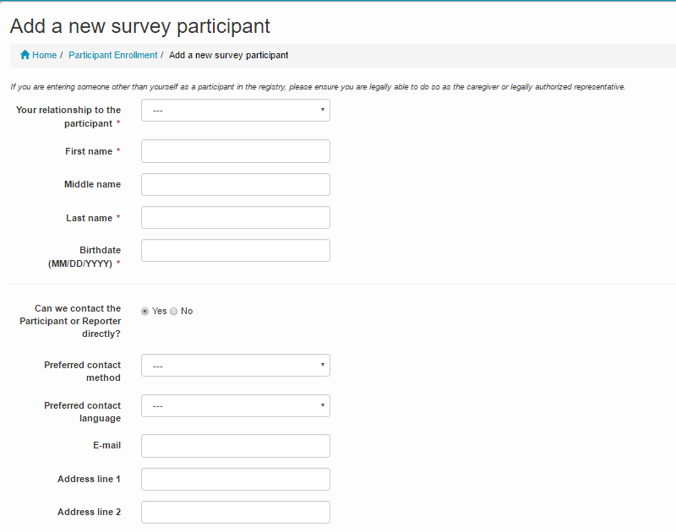

- Access Surveys by clicking on “Take Surveys.”
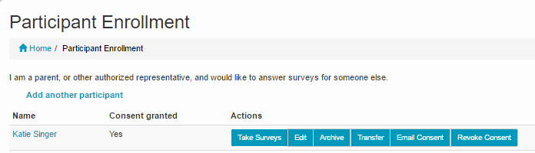

- Complete the surveys applicable to the Study Participant. For example, and adult would not complete the Quality of Life Pediatric survey.
  - NOTE: The Reporter is listed in the top right hand corner of the page and the Study Participant is listed on the left side of the page. If someone is answering surveys for him or herself, both the Reporter and Study Participant fields will reflect the same name.
Reporter
Study Participant
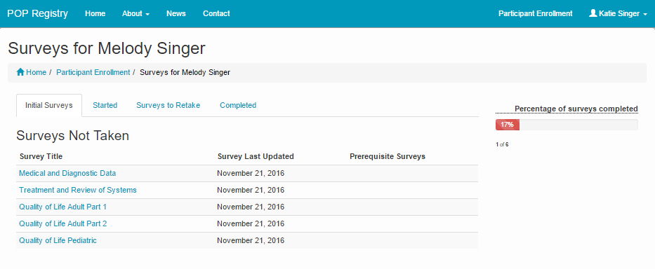

- Under “Survey Title” click on the name of the survey to open the survey. Complete the survey. Questions marked with a red * are require a response.

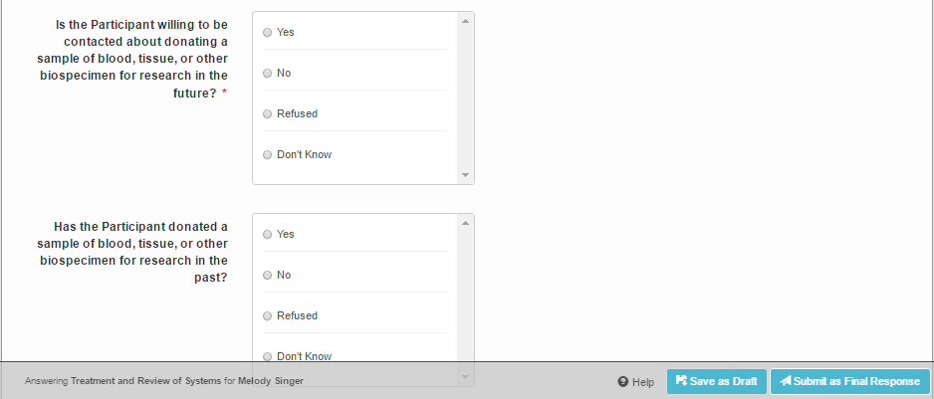
- When each Survey has been completed, click on the Submit as Final Response button. If not completed, Surveys can be saved as drafts by clicking the Save as Draft button.

